Lab #10 – Matt Cunningham
Digital Electronics
BCD To Seven Segment Display

Objectives:
- To design a BCD to seven-segment decorder by writing the expressions for each segment of the seven-segment display and reducing them, then creating a VHDL file for each expression.
Equipment Used:
- Quartus 18.1 Software with ModelSim
- DE10 board
Procedure:
- Produce a truth table that converts from BCD (using inputs A, B, C, D) to 7 segment display (segments a, b, c, d)
- Create the Boolean expression for each conversion
- Create a K-map for each conversion
- Using the K-maps, create reduced terms for each conversion segment
- Create a VHDL file and code to generate the applicable circuit for the conversion of each segment
- Generate a ModelSim simulation of the inputs and outputs of the decoder
- Use Pin Planner to program and test the board
- Display images of the simulation, circuit, VHDL code and pin assignment in the Lab Report

Results:
I showed my professor the functional logic on the DE10 board. Below are all steps I took to build the functional program:
- I created the the truth table for converting BCD for all segments:
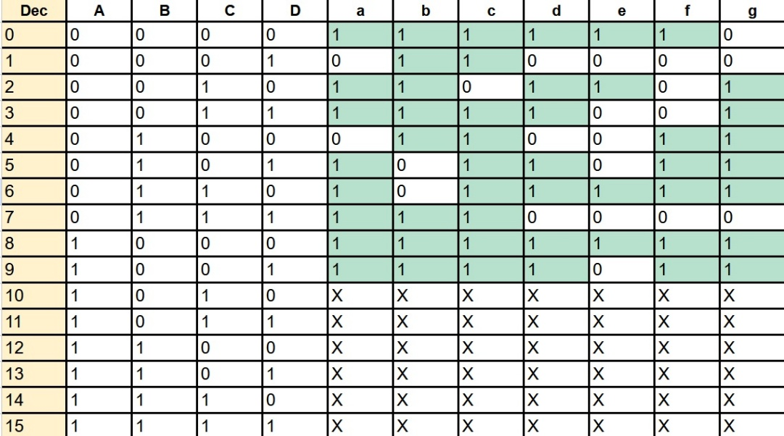

- I wrote the base expressions for each segment
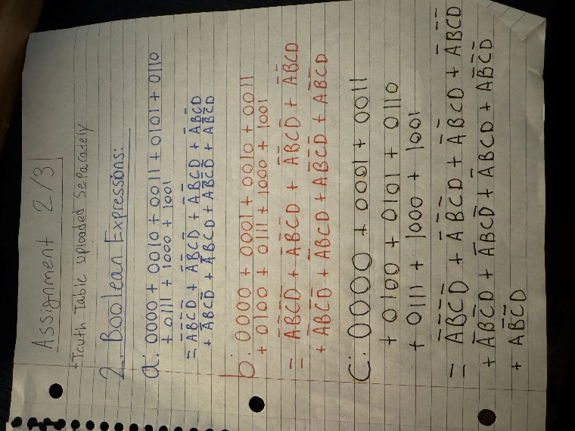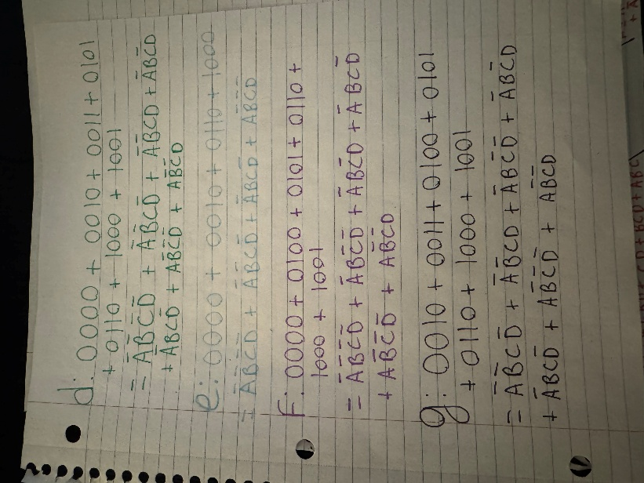

- I created the applicable K-maps for these expressions and used them to reduce
terms
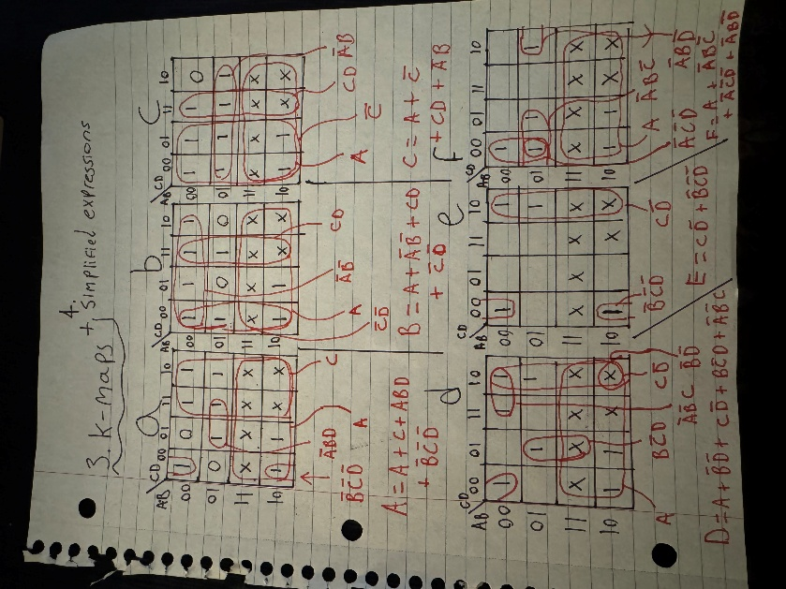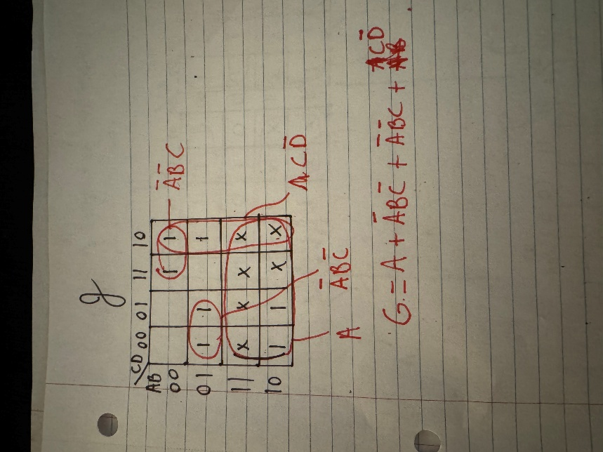

- I wrote the VHDL code to produce the circuit and ran the circuit simulation:

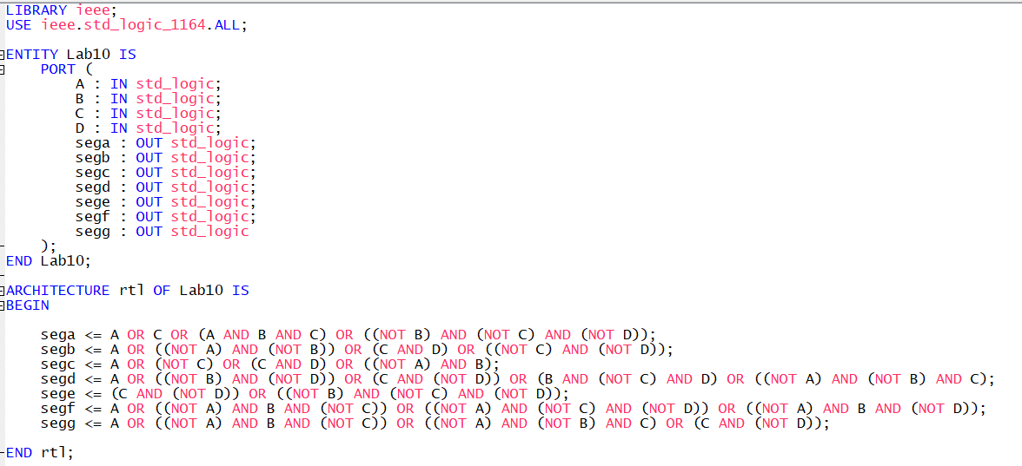
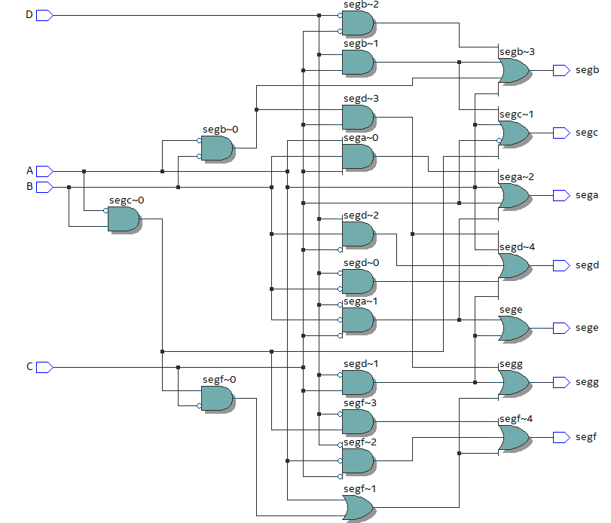

- I ran the ModelSim simulation to produce the timing diagram:
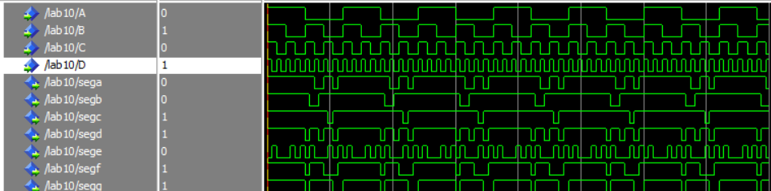

- I set the PINOUT in Pin Programmer
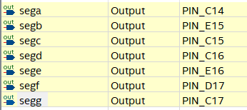

- Finally I connected the DE10 board and tested the results, which resulted in the correct seven segment display LEDs activating when various combinations were done with the switches.

Conclusion:
The board was successfully programmed as intended. It is concluded that from starting with a truth table and using methods like K-maps and grouping, you can create very complex circuits. Using VHDL, you can streamline the process of creating this circuits by avoiding having to manually create block diagram files.

